ENGR30003 Numerical Programming Assignment 2

Semester 2, 2017

Harfiyanto Dharma Santoso (772503)

1. **Roofinding**
2. **Analytical solution for θ = 0°**

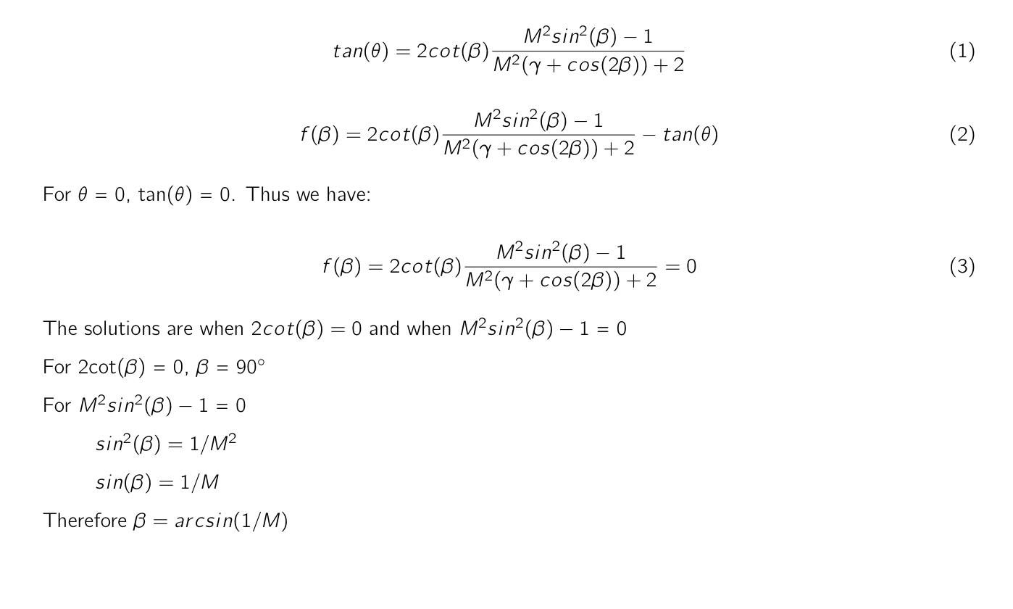

1. **Graphical Solution**

Graph of M = 1.5 for θ = 5°, 10° and 15°

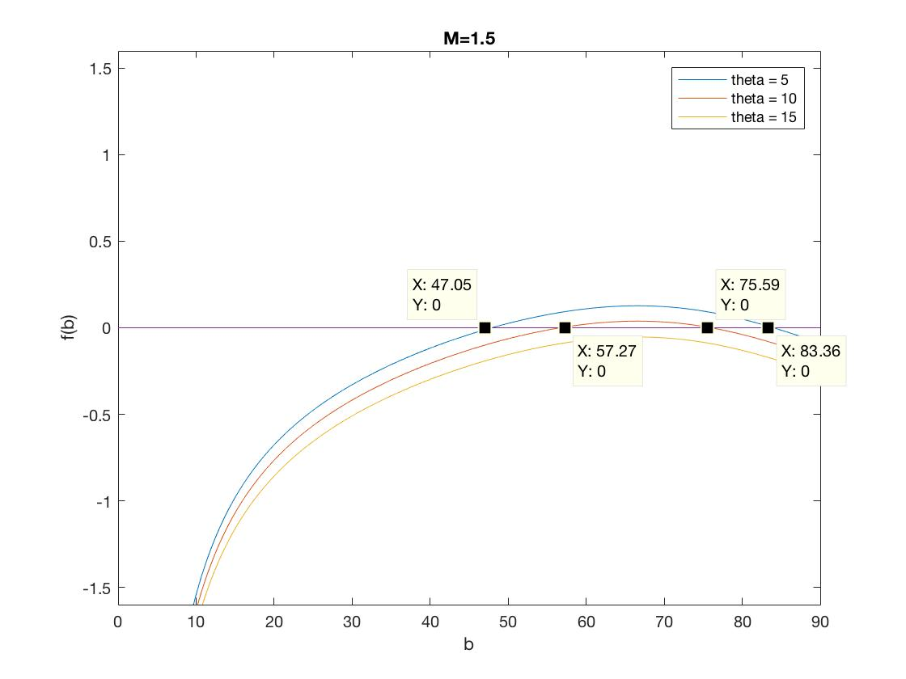

Graph of M = 5.0 for θ = 20°, 30° and 45°

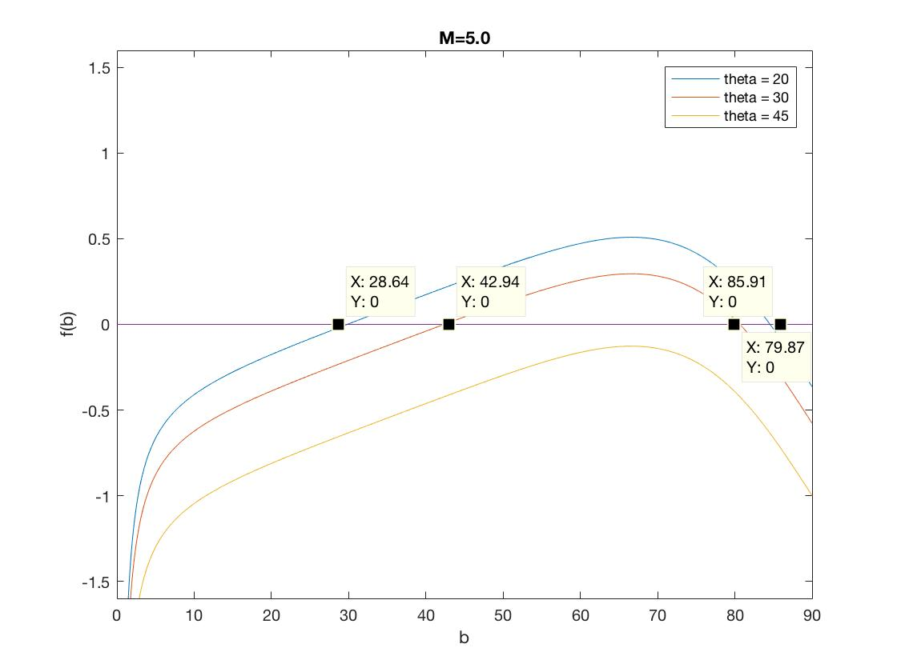

We can see that for higher theta, βL increases and βU decreases until a certain point where there is no longer solution. This point is what is referred to as θmax. From the plot we can say that the θmax for M = 1.5 is around 12.5° and the θmax for M = 1.5 is around 40°.

1. **C program to solve shock-wave equation**
2. The appropriate guess for βL should be $β_{L}=\arcsin\left(\frac{1}{M}\right)=\arcsin\left(\frac{1}{5}\right)=11.5°$

The appropriate guess for βU should be $β_{U}=90°$

1. The plots are:

For M = 1.5

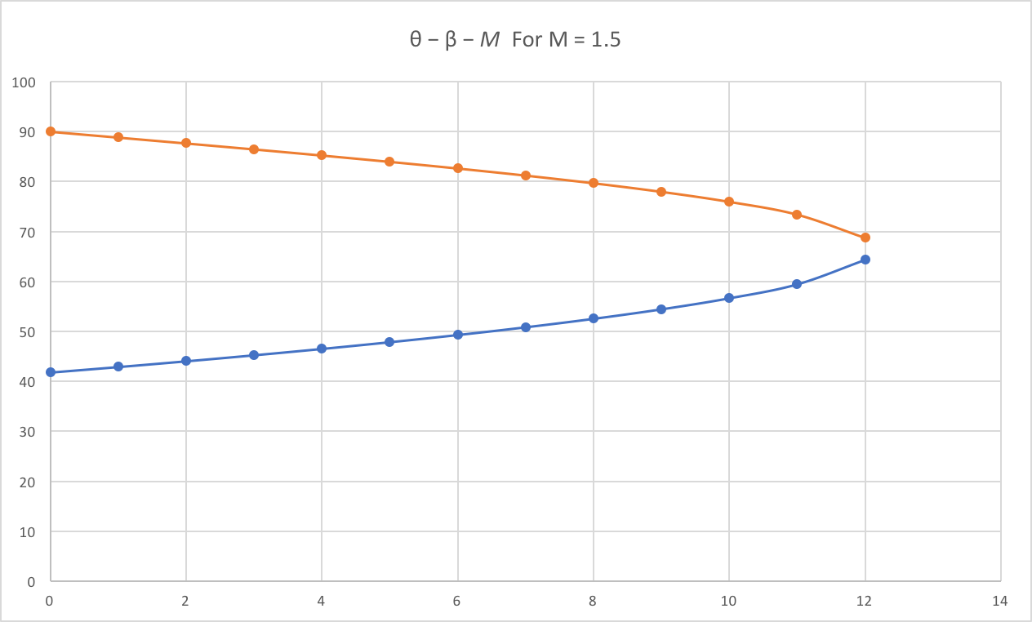

For M = 3.0

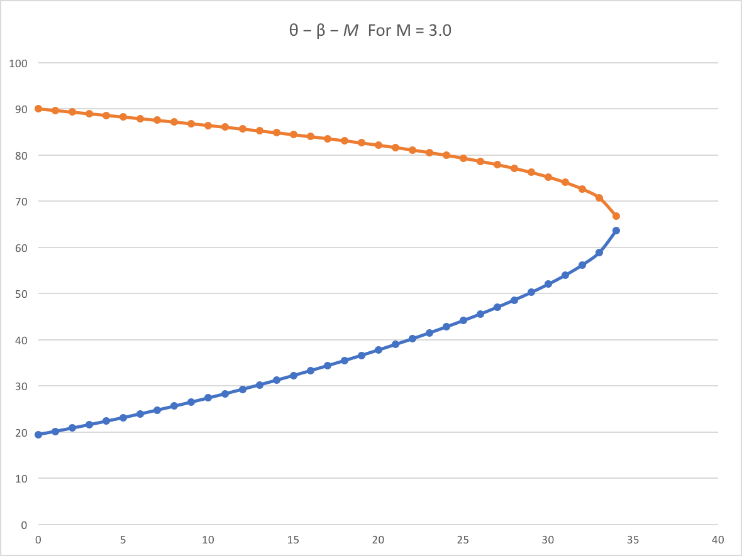

For M = 4.0

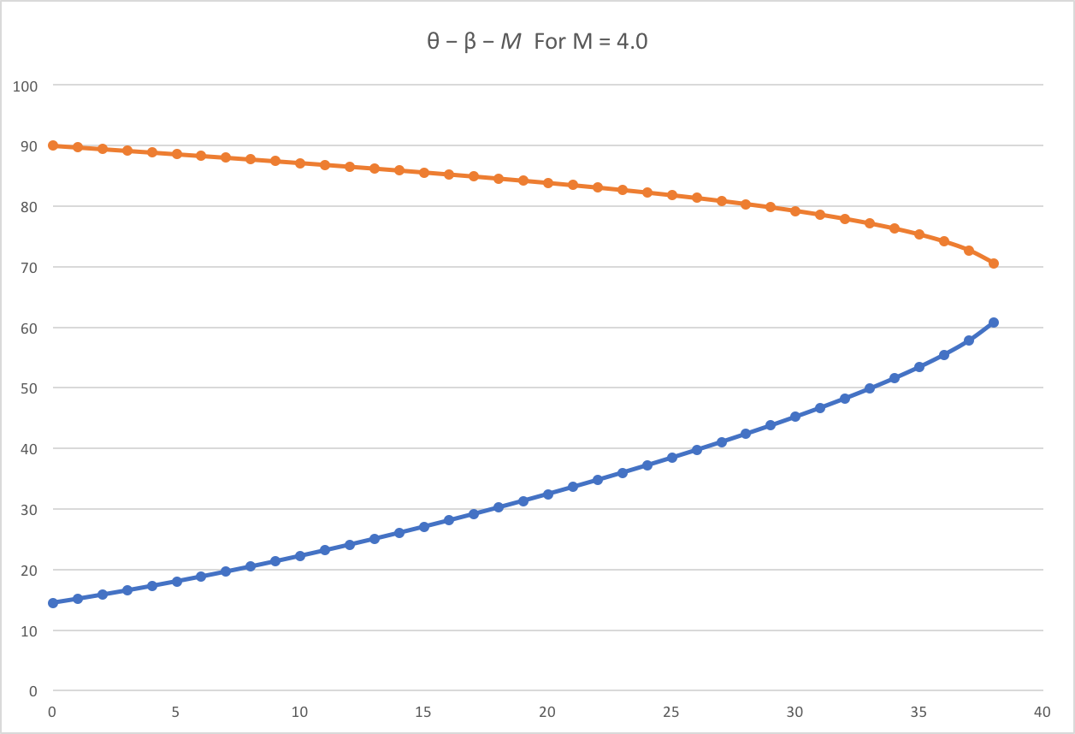

For M = 5.0

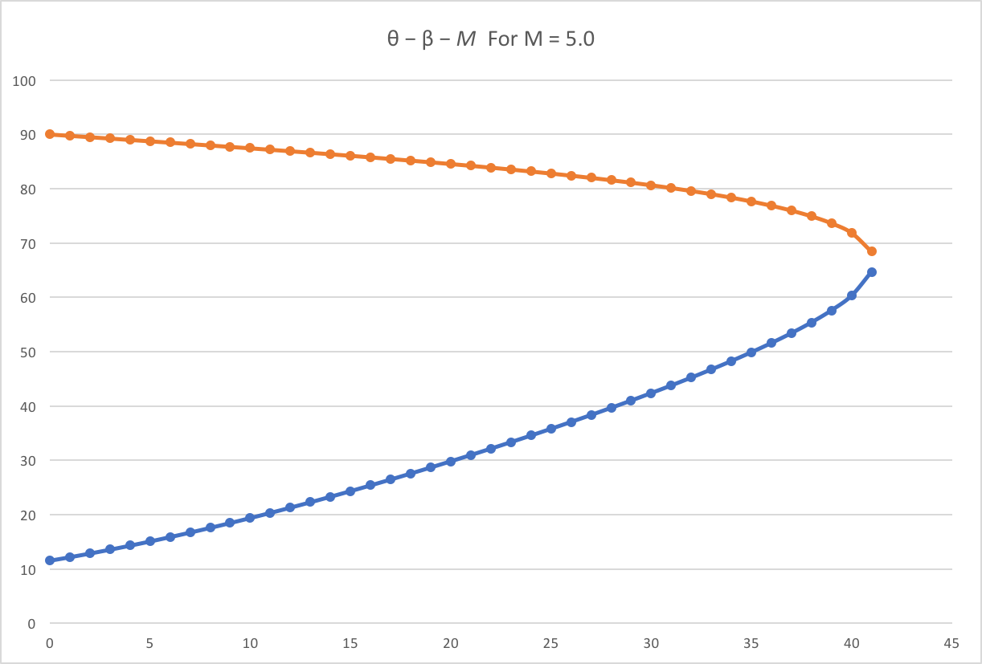

For M = 7.0

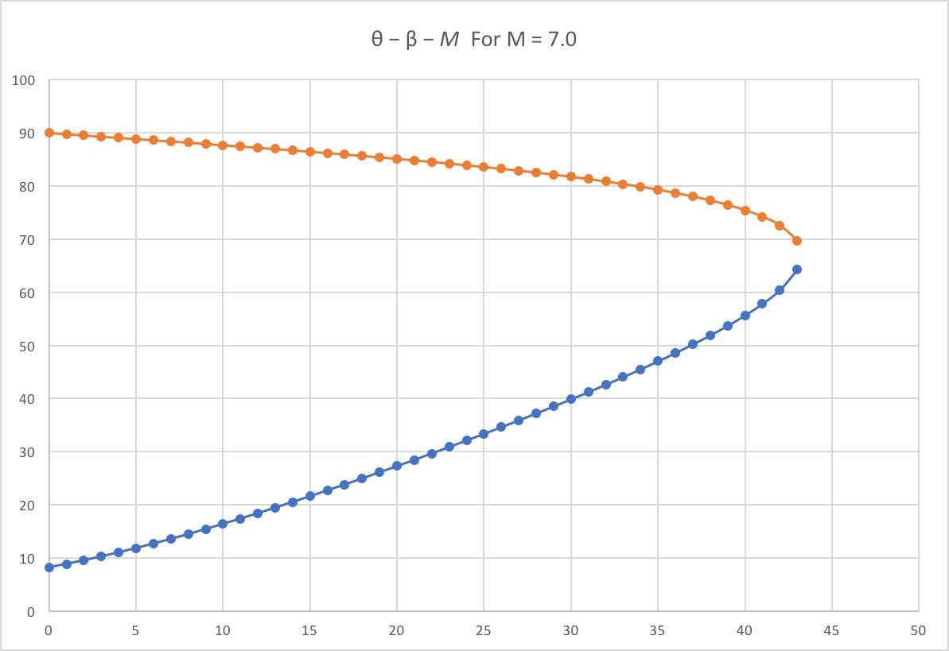

For M = 8.0

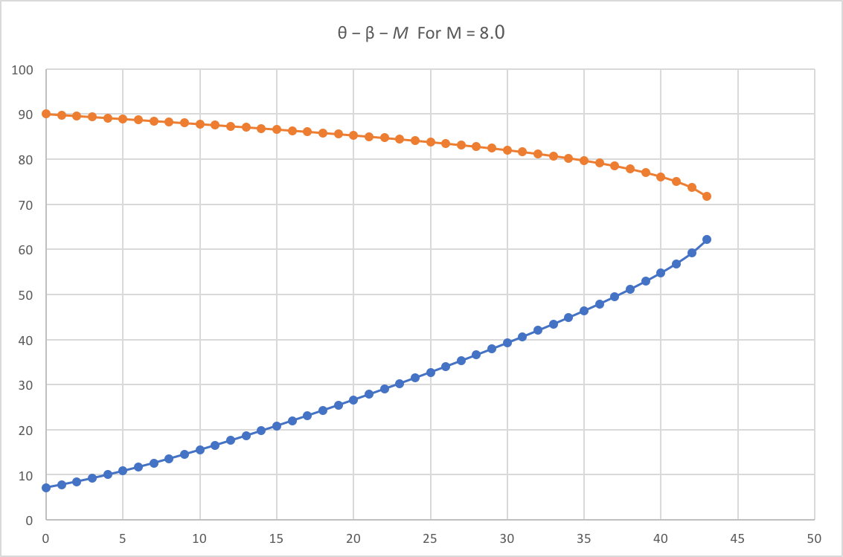

1. **Linear Algebraic System**

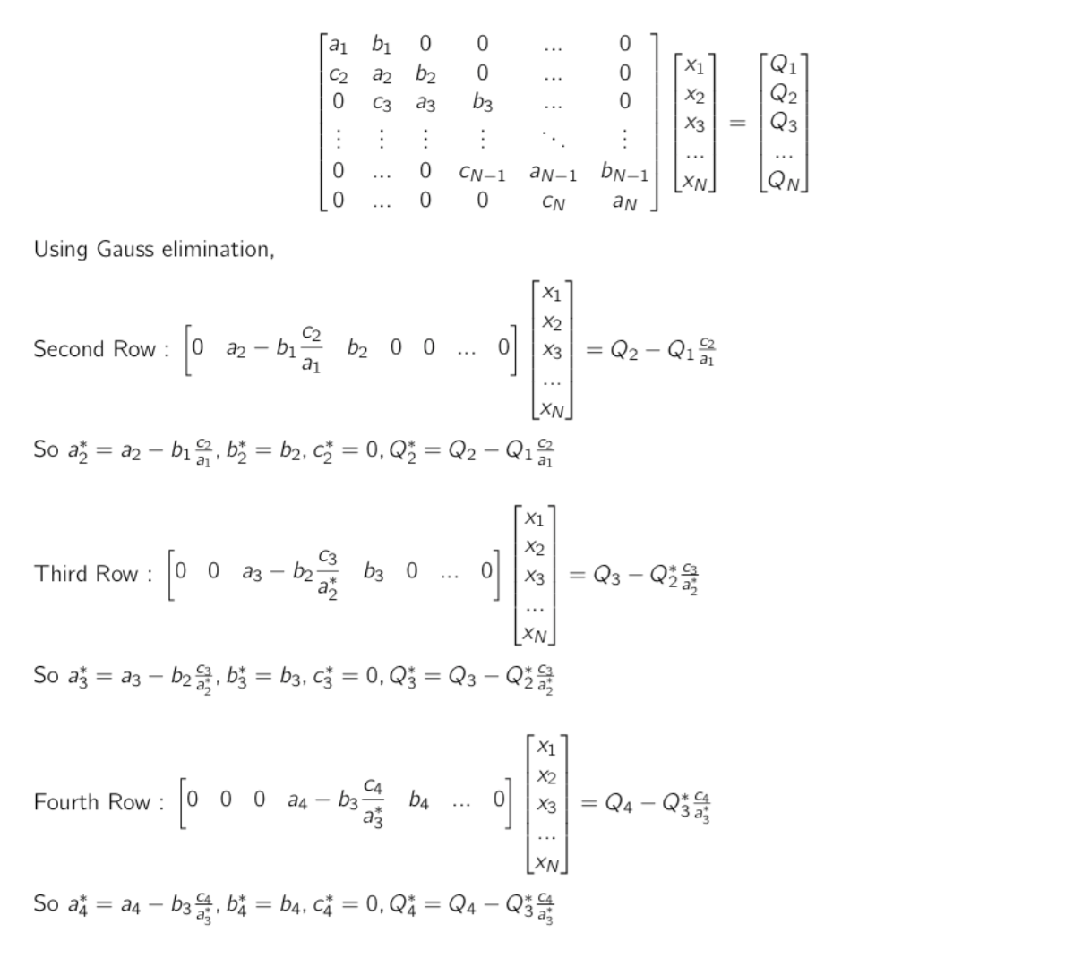

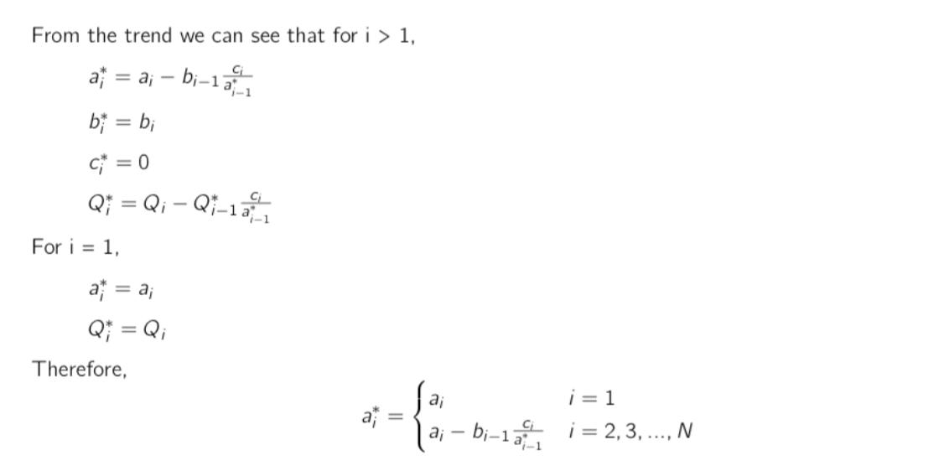



1. **Regression**

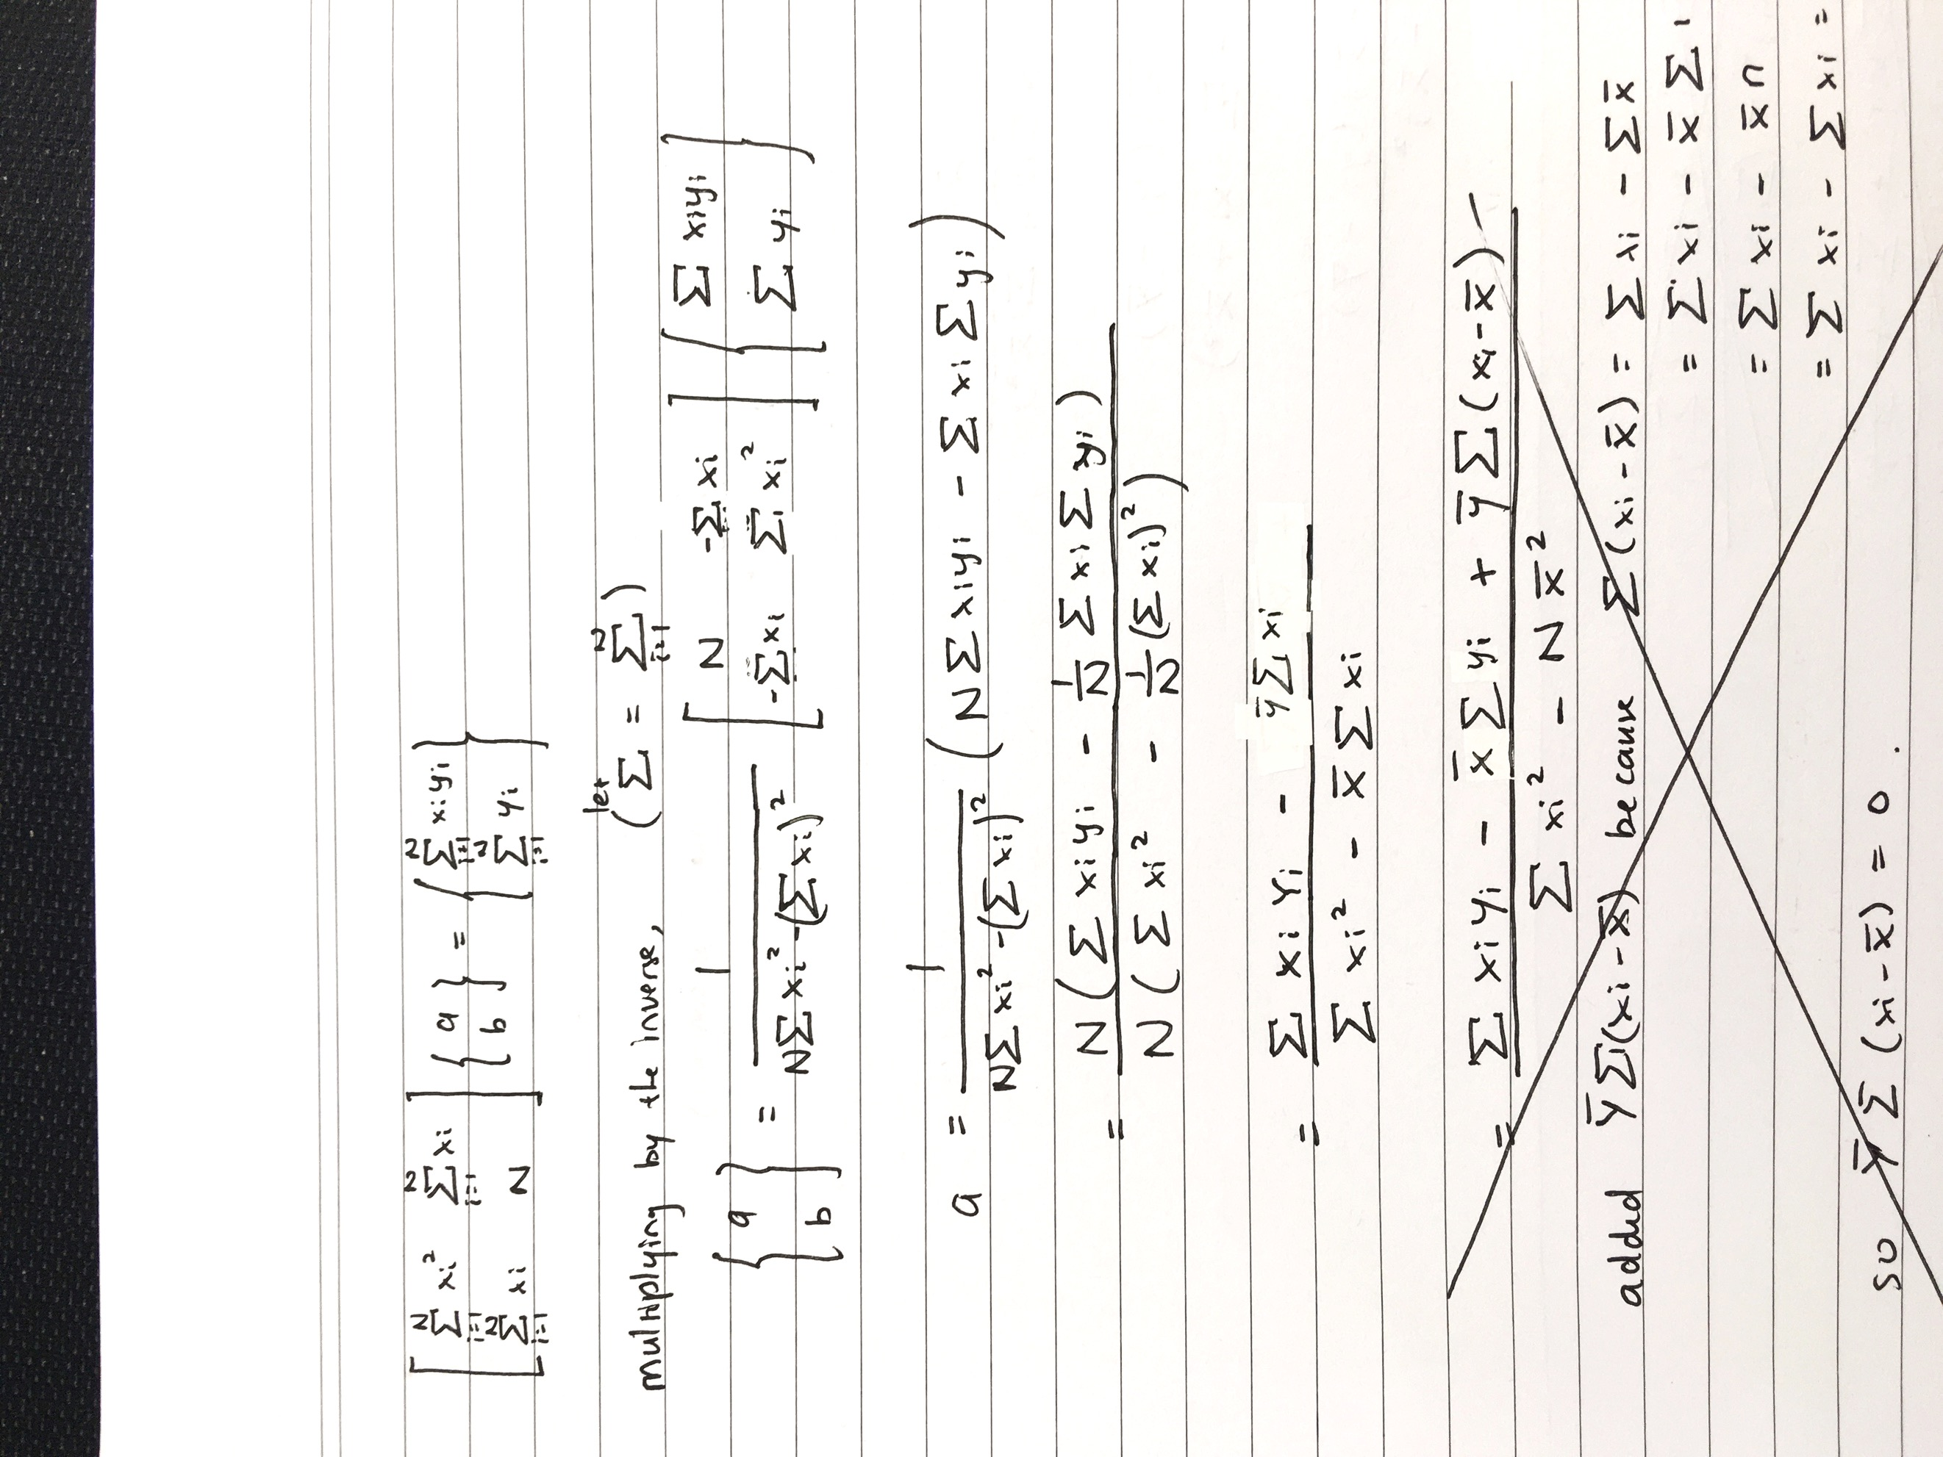

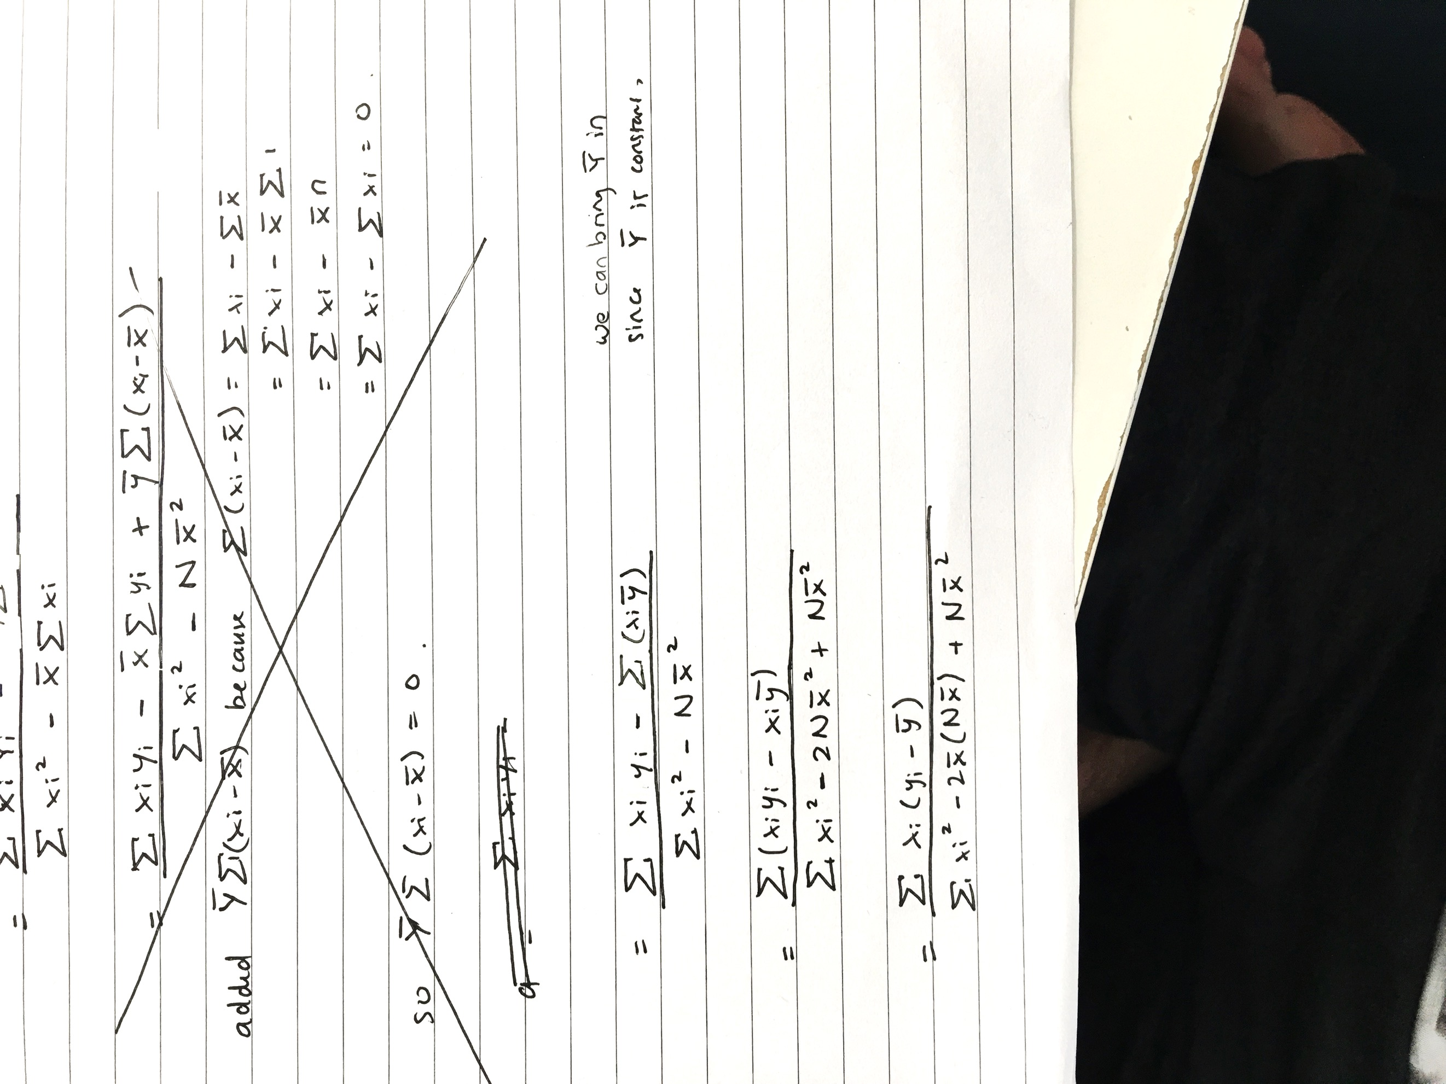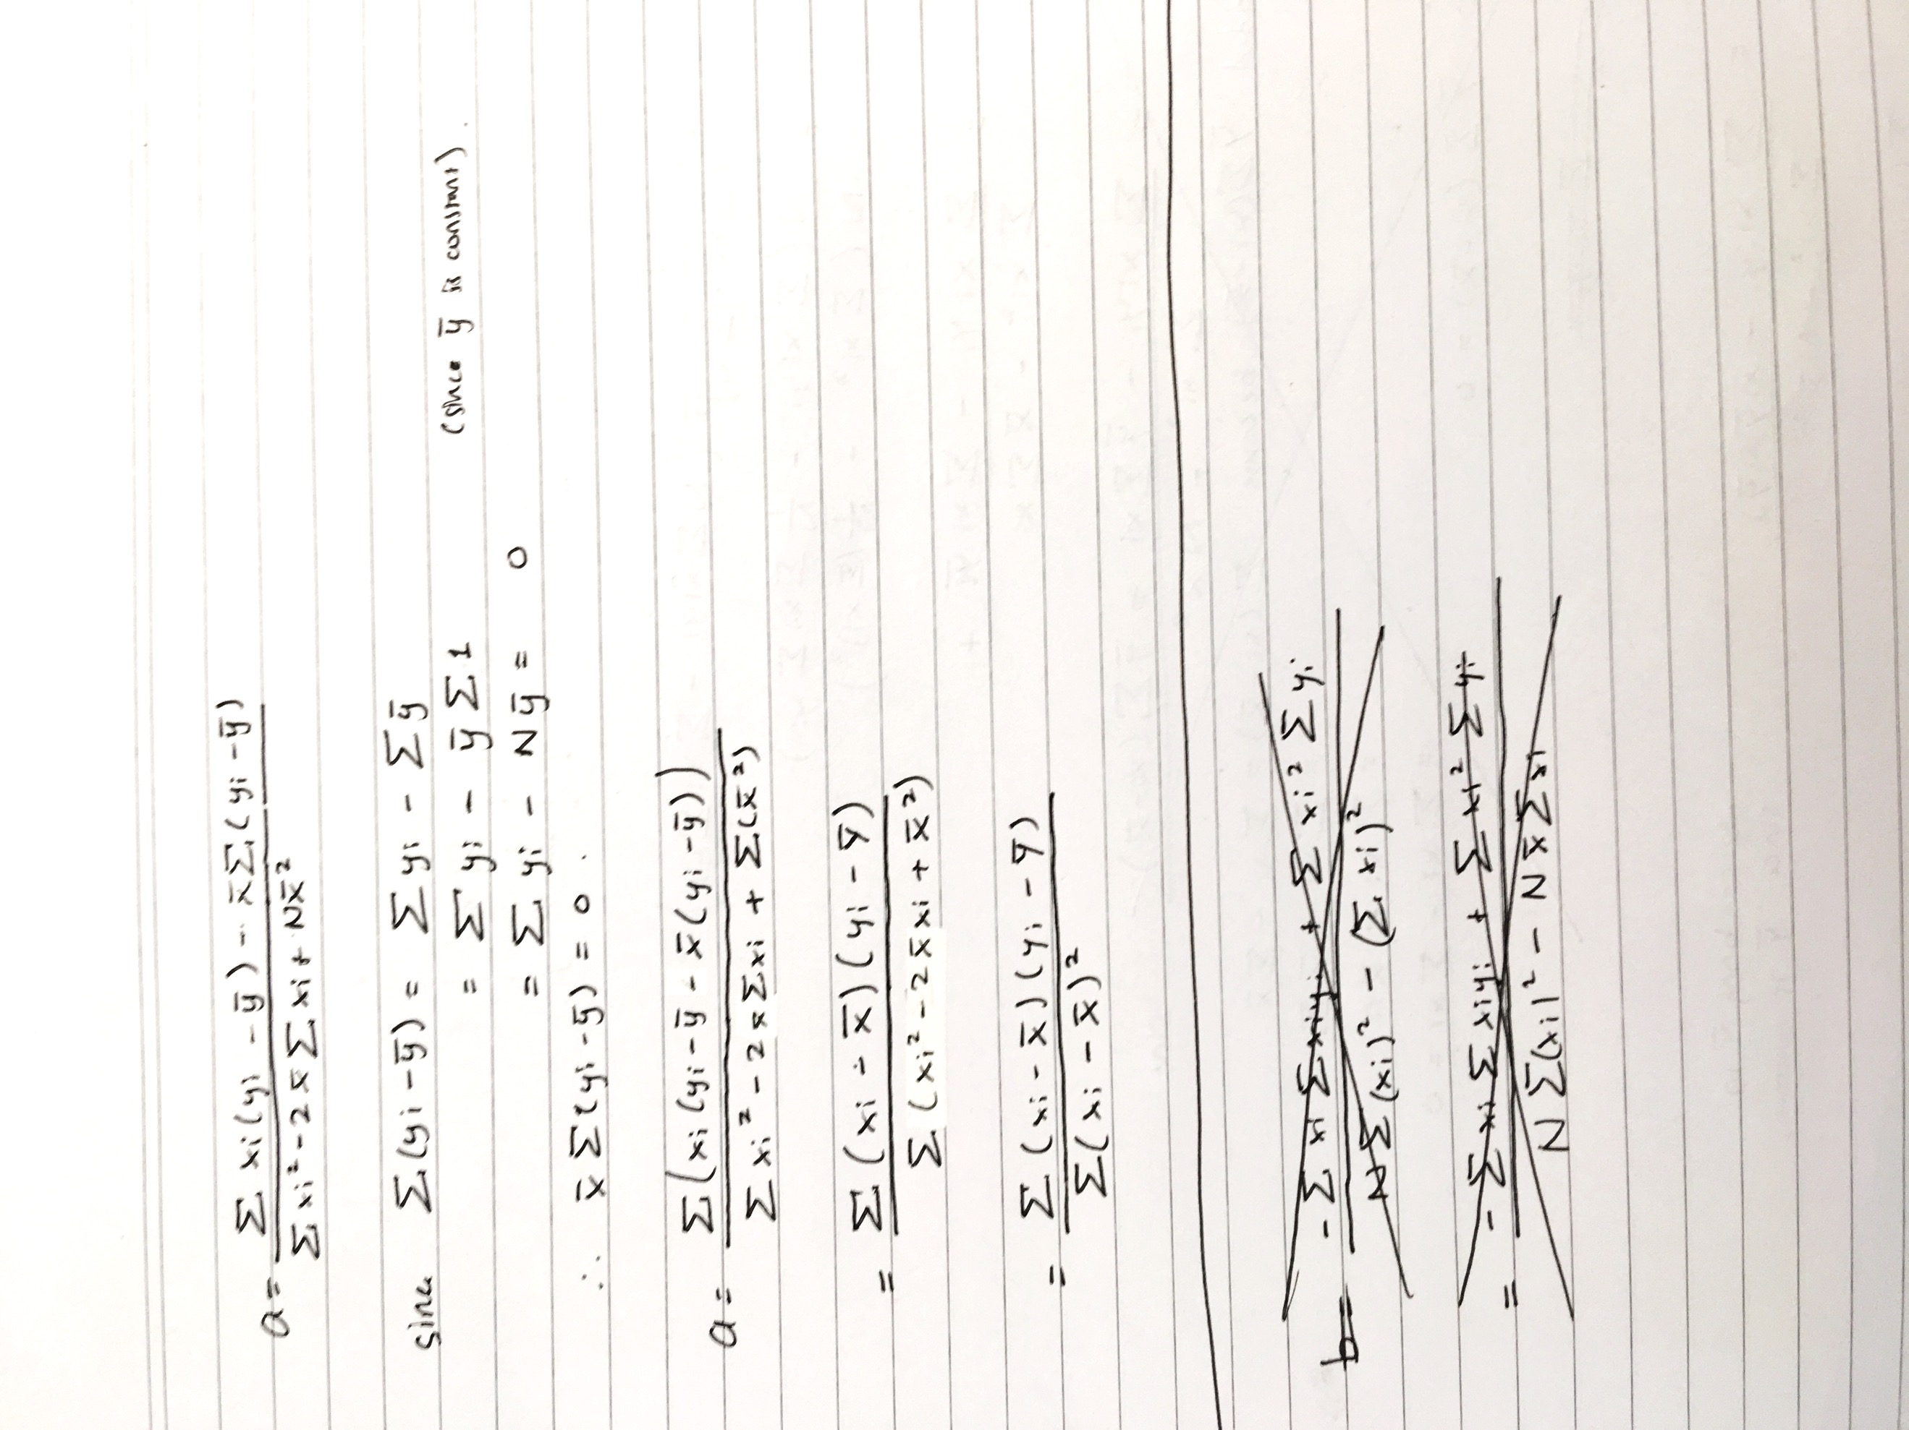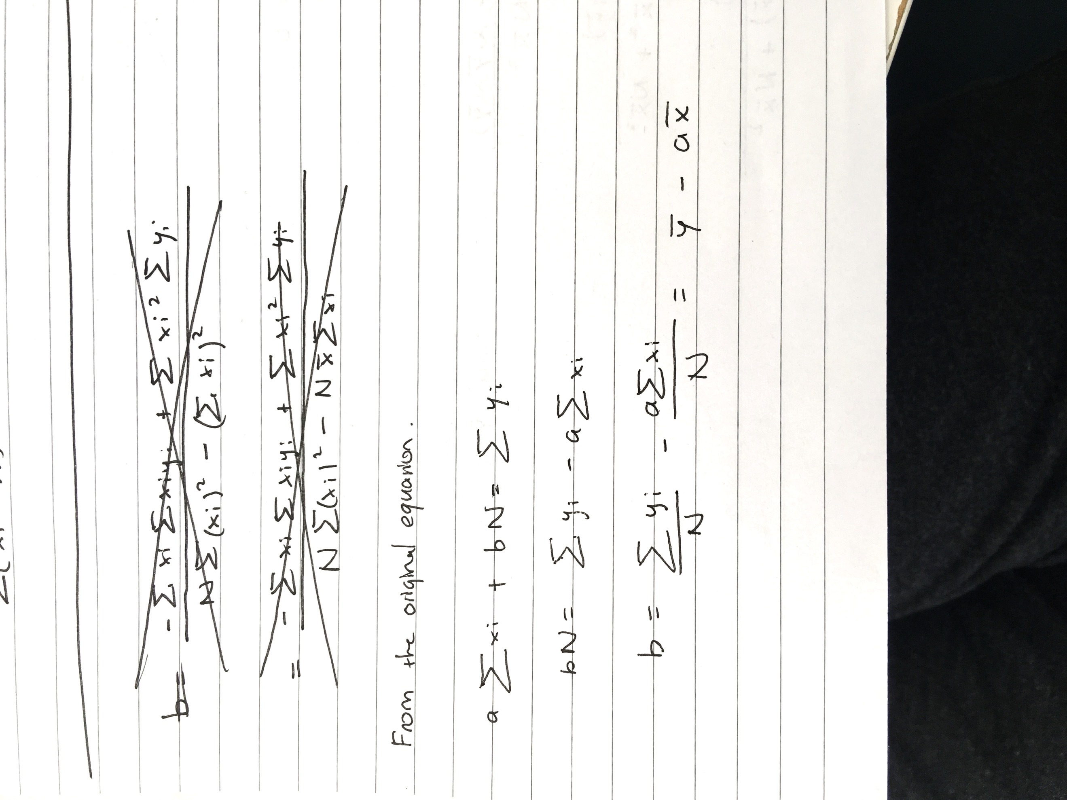

The linear regression fails when a is undefined i.e. when $\sum{{\left(x_{i}-x\right)}^{2}=0}$

1. **Interpolation**

To approximate xo using Second-order Lagrange Interpolation, we choose the point closest to xo as the middle point (where suitable). For example, if the original points are 1, 3, 5, 7, 9 and xo is 6.5, we choose the points (5,7,9) and use Second-order Lagrange for these three points to estimate f(xo). Some exceptions apply such as when xo is bigger than the biggest original points in which case we choose the second biggest point as the mid-point.

As we can see from the plot, the functions intersect at the point (3,17) and (8,17) which are the two original points as expected. Note that the Second-order Lagrange Interpolation is only defined between 3 points chosen (x = 1, 3 and 8) and that there are two Cubic Spline Interpolation plots because each of the are only defined between two points [1,3] and [3,8].

In my opinion the Cubic Spline Interpolation is more accurate because the general trend observed from the original data is that the actual graph is plateauing as depicted in the Cubic Spline Interpolation plot. While it is inconclusive to compare these two plots without the actual plot/function, in general, Spline interpolation is more accurate than Lagrange interpolation and the higher order of the system is, the more accurate it is.

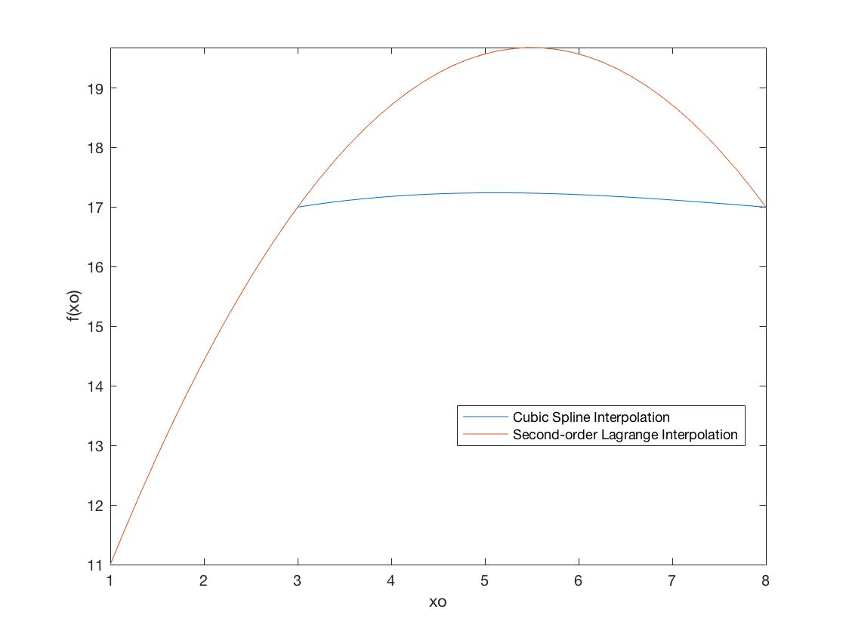

1. **Differentiation, differential equation**
   1. **Discussion and Graph**

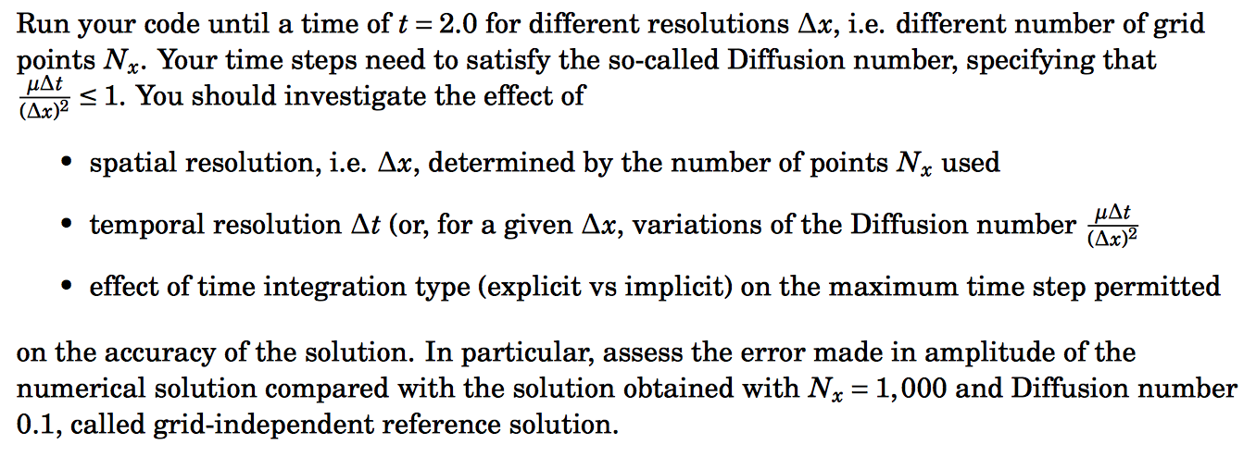

We would investigate the effect of

* Spatial Resolution i.e. $∆x$
* Temporal Resolution $∆t$
* Time Integration Type (Explicit vs Implicit)

On the accuracy of the solution.

For the grid-independent reference solution with Nx = 1000 and diffusion number $D=\frac{μ∆t}{{\left(∆x\right)}^{2}}=0.1$ the Nt needs to be 100000.

Plotting the result using the three methods at 100th timestamp (explicit fixed end, explicit variable end and implicit fixed end) we have

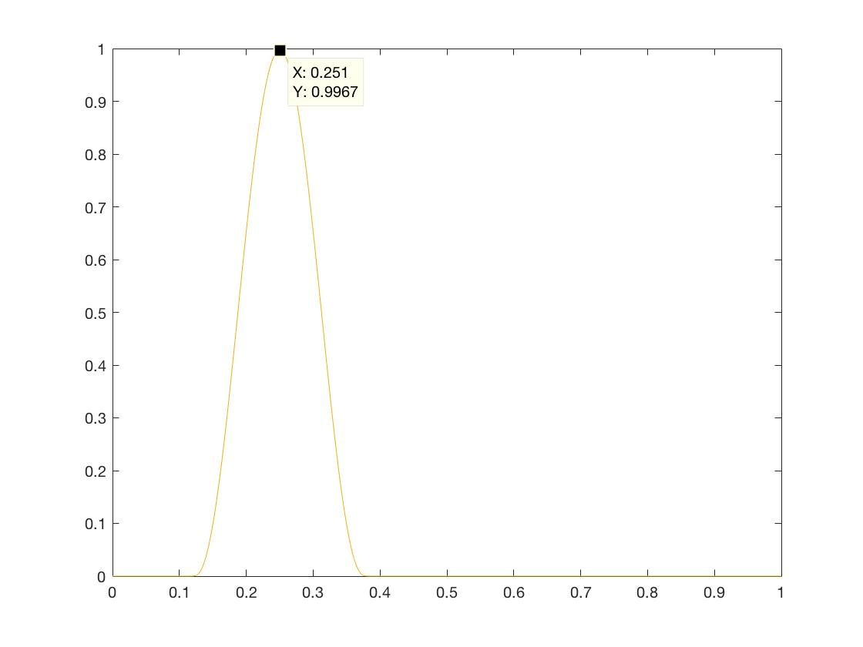

We see that in this case, the three methods produced approximately the same graphs. The amplitude of the graph is 0.9967 from which we will compare our results.

Investigating Spatial Resolution

When trying to vary Nx (thus changing $∆x$), I tried keeping the Diffusion number constant to isolate the effect of $∆x$.

1. Nx = 500, Nt = 25000, D = 0.1

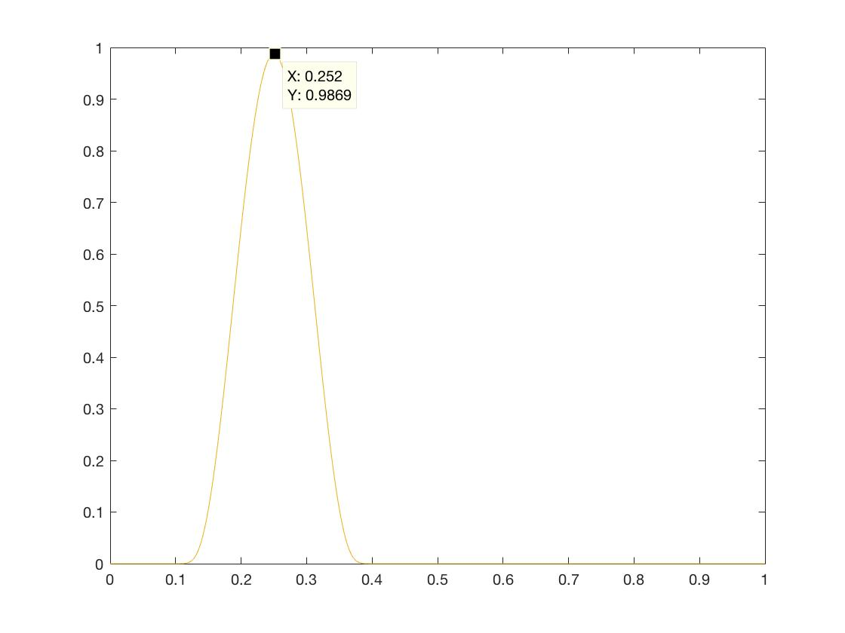

1. Nx = 100, Nt = 1000, D = 0.1

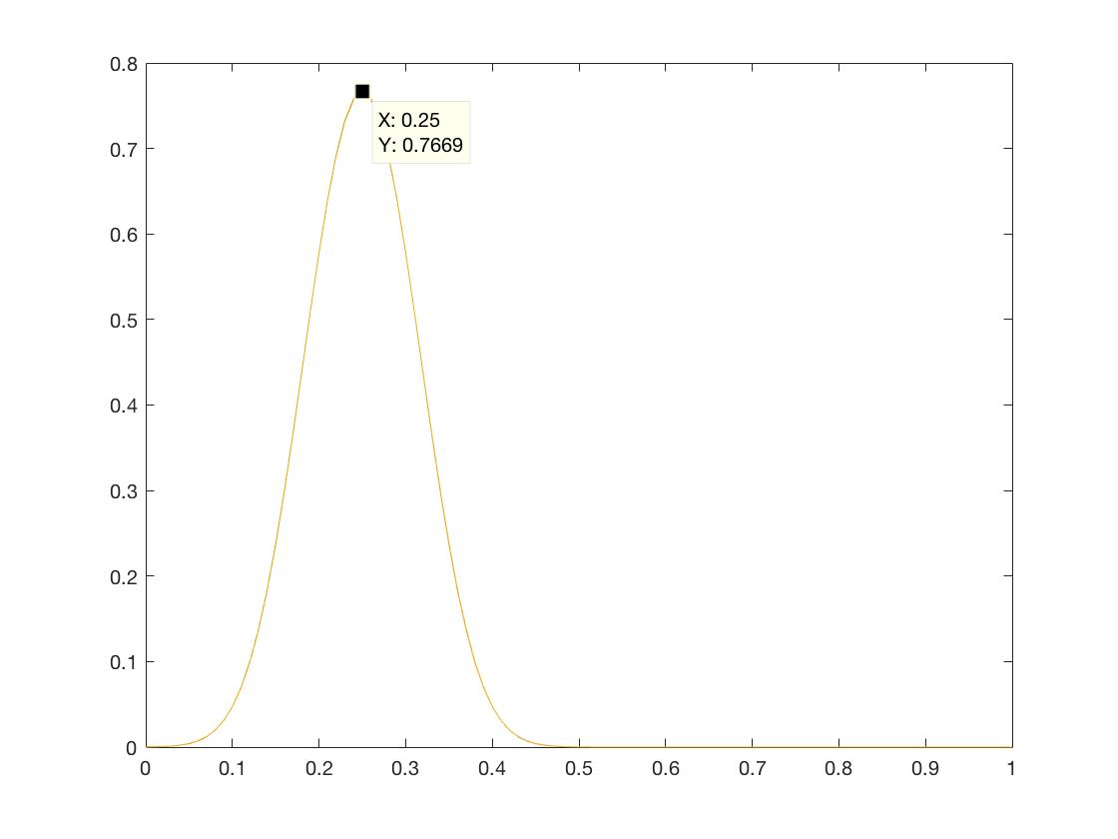

1. Nx = 50, Nt = 250, D = 0.1

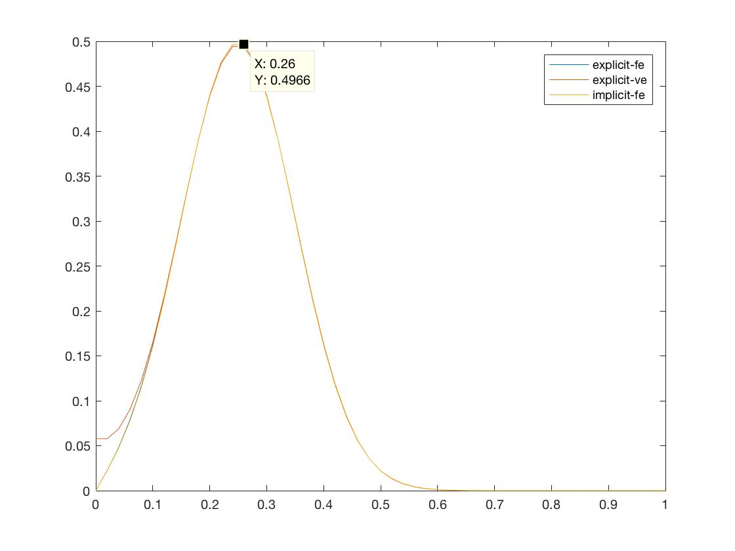

From these three graphs, we can conclude that compared to the amplitude of the grid-independent reference solution, the error becomes larger the smaller Nx becomes which means the larger $∆x$ is, the larger the error.

$$ε_{1}= 0.9967-0.9869= 0.0098$$

$$ε_{2}= 0.9967-0.7669=0.2298$$

$$ε_{3}= 0.9967-0.4966=0.5001$$

Note that in our first two graphs, the three methods produced approximately the same result. However, in the last graph (Nx = 50), the explicit variable end method produced different result at low x-value when compared to the other two methods. The three methods produce similar result at other values of x. This may be caused by the fact that they use different assumptions (fixed end vs variable end).

Investigating Temporal Resolution

In this analysis, we keep Nx fixed and vary Nt which will change the value of $∆t$ and D. While doing the experiments I noticed that at certain Diffusion number, the result of explicit methods (fixed and variable end) diverges to invalid values (infinite or nan). This shows the advantage of implicit method compared to explicit method which is stability.

For example, when trying to plot Nx = 1000, Nt = 10000, D = 1, the values for both explicit methods blew up.

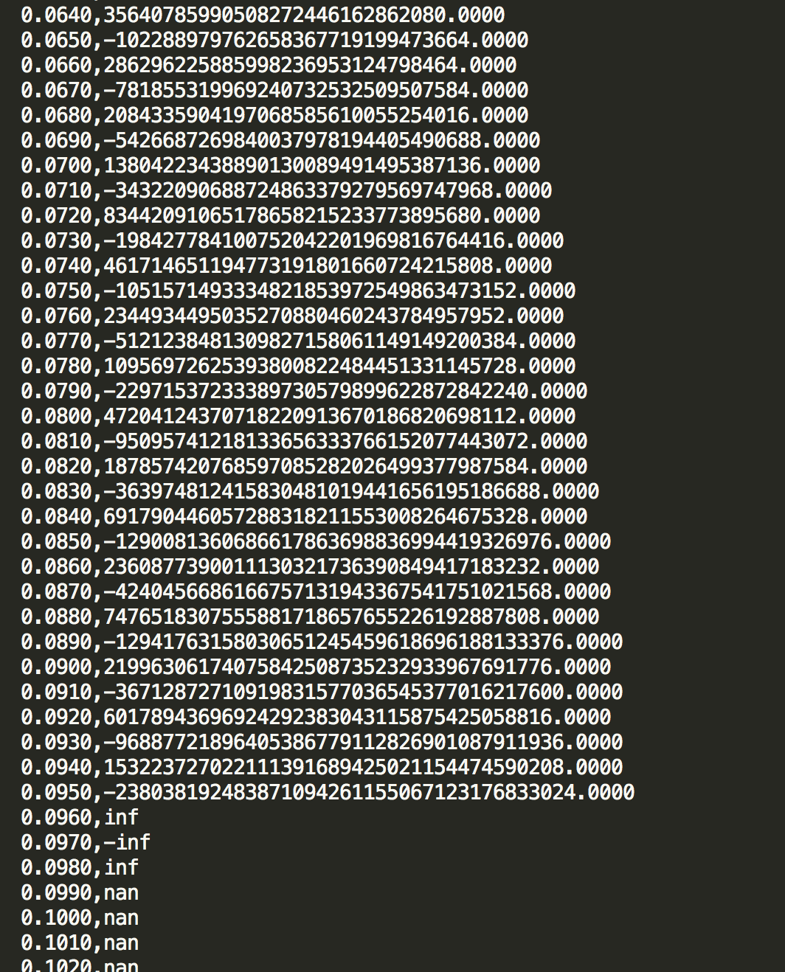

So, we can only plot the graph for the implicit method

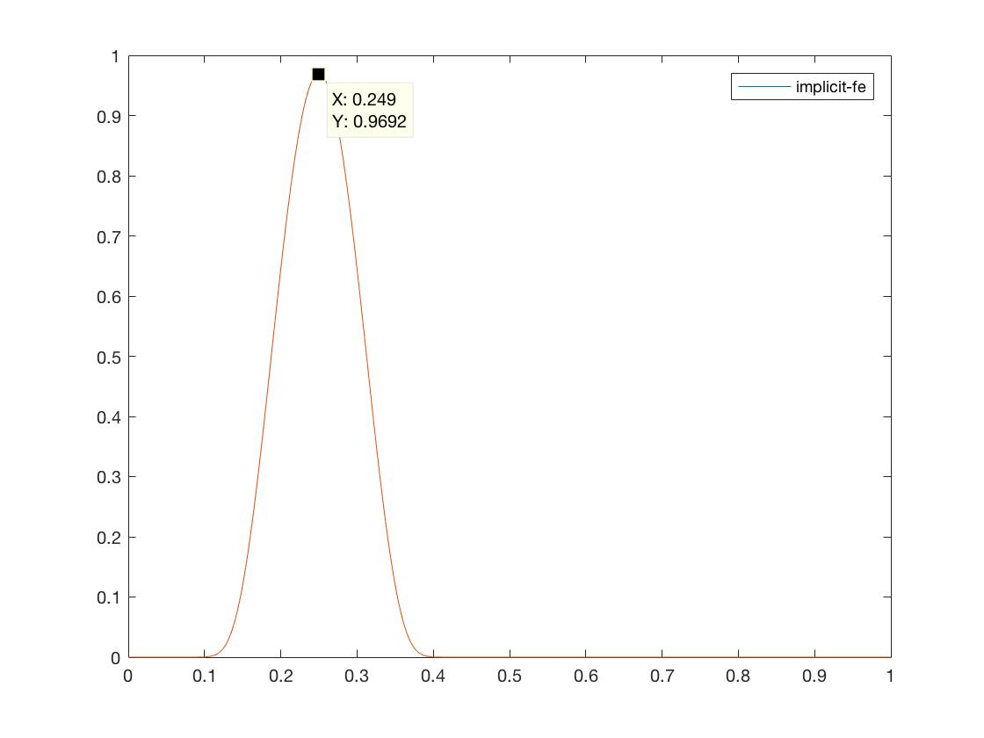

I tried this for several D values (0.25, 0.5, 0.625, 1) and found out that D must be lower than approximately 0.5 for explicit methods to get a valid solution.

1. Nx = 1000, Nt = 40000, D = 0.25

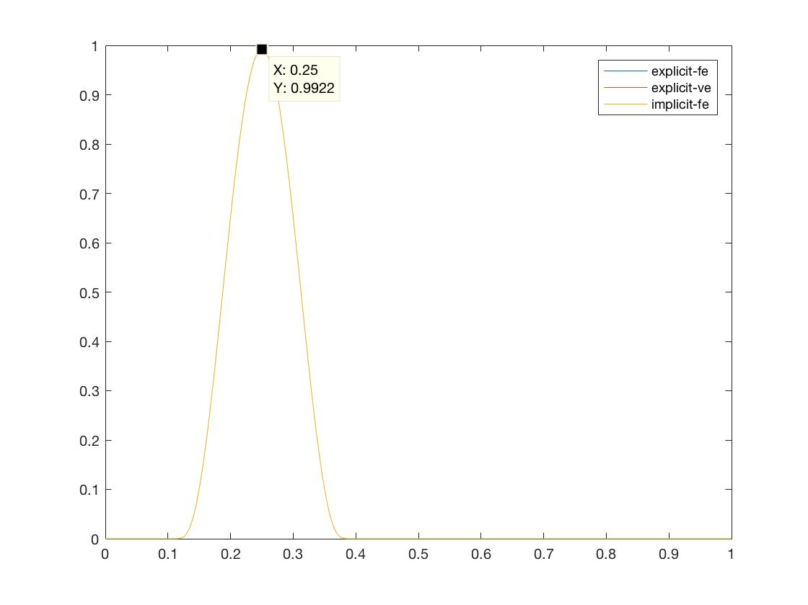

1. Nx = 1000, Nt = 20000, D = 0.5

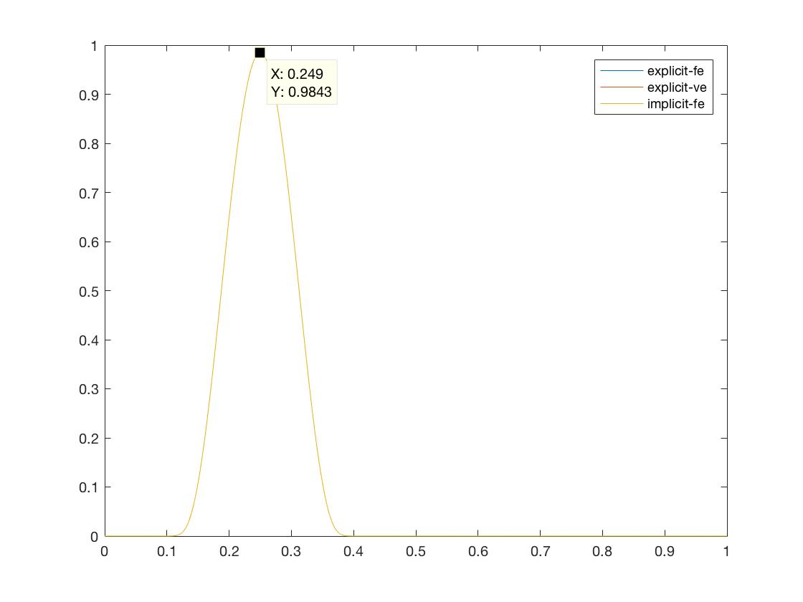

1. Nx = 1000, Nt = 16000, D = 0.625

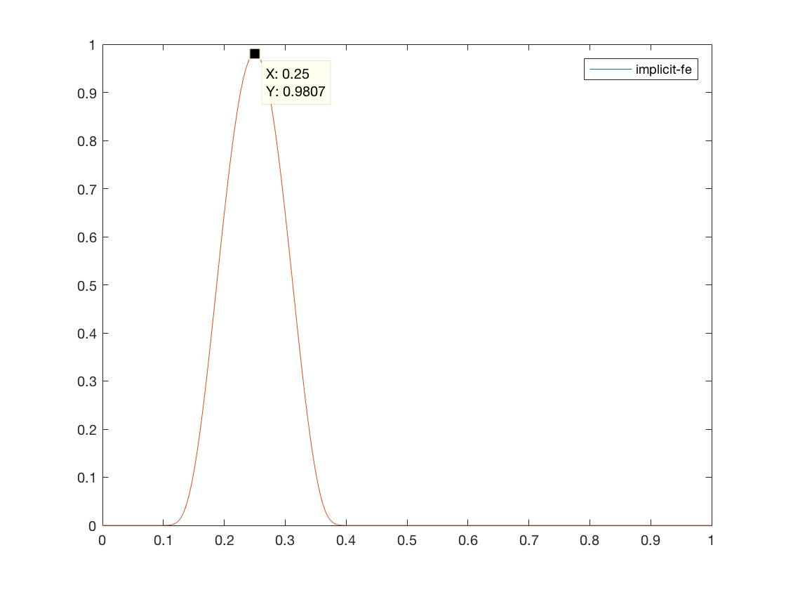

1. Nx = 1000, Nt = 10000, D = 1



Error (compared to reference):

$$ε_{1}= 0.9967-0.9922= 0.0045$$

$$ε_{2}= 0.9967-0.9843=0.0124$$

$$ε_{3}= 0.9967-0.9807=0.016$$

$$ε_{4}= 0.9967-0.9692=0.0275$$

From the trend, we can see that the larger Nt is, the smaller the error thus the more accurate it is. Therefore smaller $∆t$ is, the more accurate the solution is.

Investigating the Effect of Time Integration Type

In this analysis, we will use the same D value as the reference (D = 0.1) and compare the result with the reference. Then for this analysis, for a particular Nx there is only one maximum value of Nt. We also look at the solution at the end of the timestamp e.g. timestamp 10 for Nt = 10.

1. Nx = 10, Nt = 10, D = 0.1
2. Nx = 20, Nt = 40, D = 0.1
3. Nx = 40, Nt = 160, D = 0.1

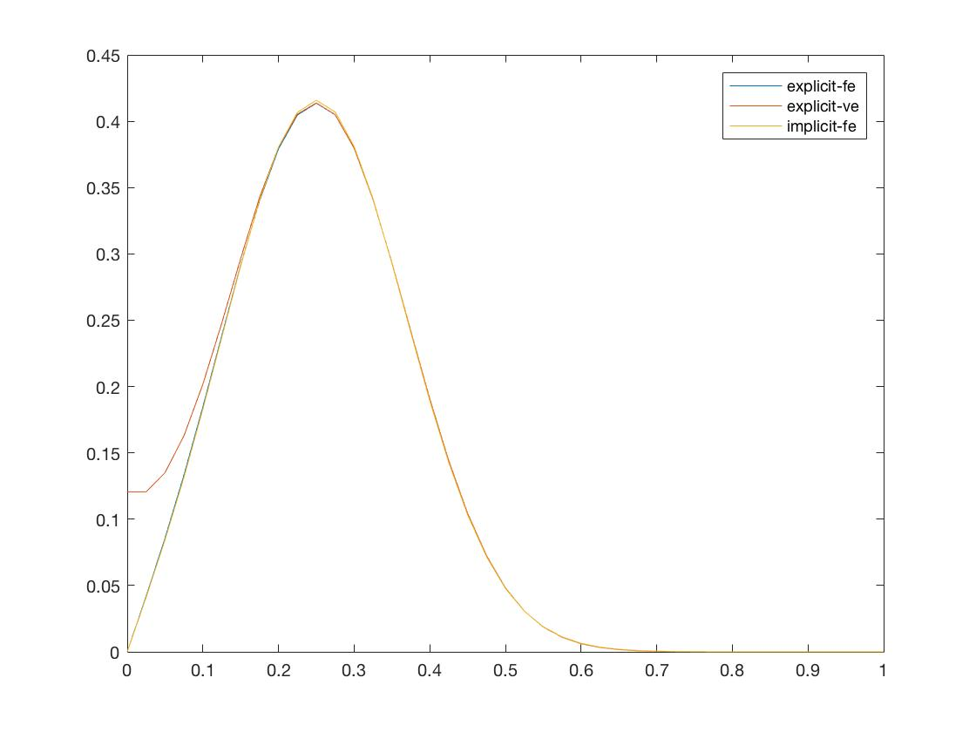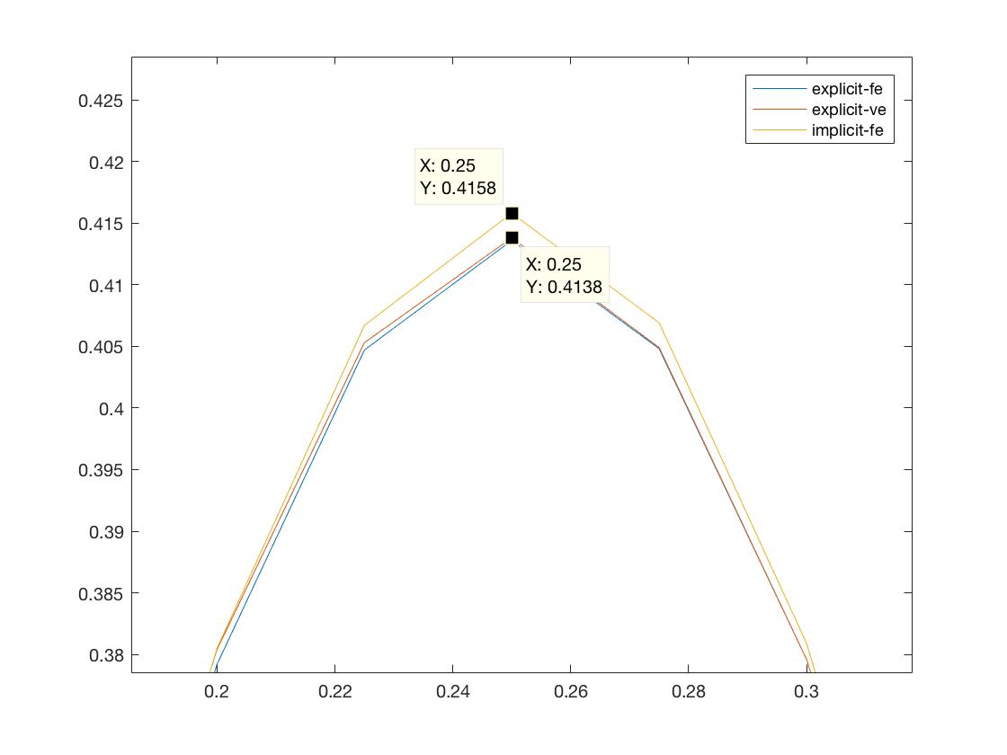

1. Nx = 80, Nt = 640, D = 0.1

